Week 2 task3:
import java.io.*;
import java.util.*;
import static java.util.stream.Collectors.toList;
import static java.util.stream.Collectors.joining;

class Result {

public static List<Integer> compareTriplets(List<Integer> a, List<Integer> b) {

int alice = 0;
int bob = 0;

for (int i = 0; i < 3; i++) {
if (a.get(i) > b.get(i)) {
alice++;
} else if (a.get(i) < b.get(i)) {
bob++;
}
}

List<Integer> result = new ArrayList<>();
result.add(alice);
result.add(bob);

return result;
}
}

public class Solution {
public static void main(String[] args) throws IOException {

BufferedReader bufferedReader =
new BufferedReader(new InputStreamReader(System.in));

BufferedWriter bufferedWriter =
new BufferedWriter(new FileWriter(System.getenv("OUTPUT_PATH")));

List<Integer> a = Arrays.stream(bufferedReader.readLine().split(" "))
.map(Integer::parseInt)
.collect(toList());

List<Integer> b = Arrays.stream(bufferedReader.readLine().split(" "))
.map(Integer::parseInt)
.collect(toList());

List<Integer> result = Result.compareTriplets(a, b);

bufferedWriter.write(
result.stream()
.map(Object::toString)
.collect(joining(" "))
+ "\n"
);

bufferedReader.close();
bufferedWriter.close();
}
}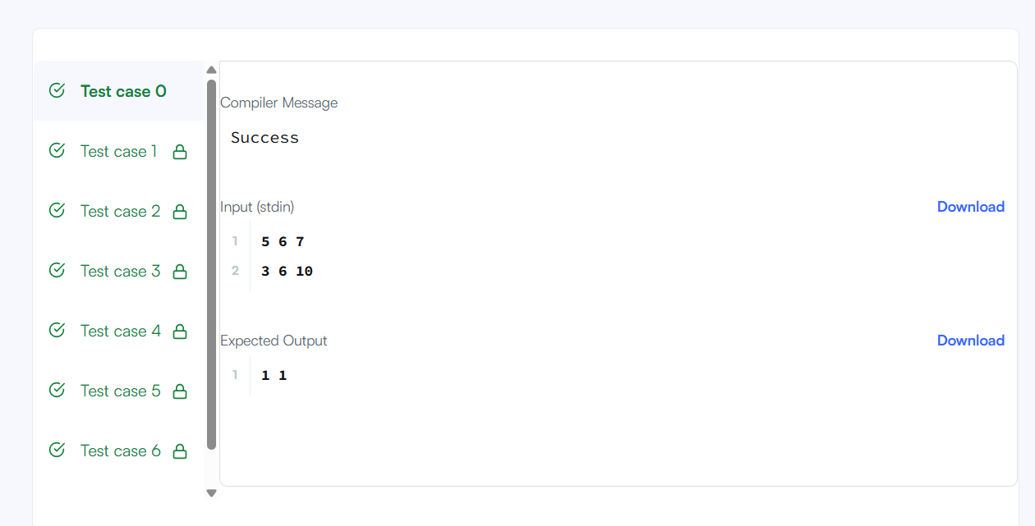

Week 2 task4:
import java.util.*;

class Solution {
public boolean containsDuplicate(int[] nums) {

HashSet<Integer> set = new HashSet<>();

for (int i = 0; i < nums.length; i++) {

if (set.contains(nums[i])) {
return true;
}

set.add(nums[i]);
}

return false;
}
}